To complete this worksheet, see the instructions in the textbook (Chapter 10 Investigation, Reynolds and others).

Question 1. Identification of Features on the Ocean Floor
Different oceanic features are numbered (1 through 10) adjacent to the figure below. Write the name for each feature using the choices listed below. Note that the numbered spaces below do not correspond to the numbered descriptions in the textbook.
Possible choices include: Abyssal plain, back-arc basin, fracture zone, hot spot, island arc, mid-ocean ridge, oceanic plateau, oceanic trench, passive continental margin, and submarine canyon and fan

Feature 5: _________________
Feature 3: _________________

Feature 1:
_________________
Feature 4: _________________
Feature 6: _________________

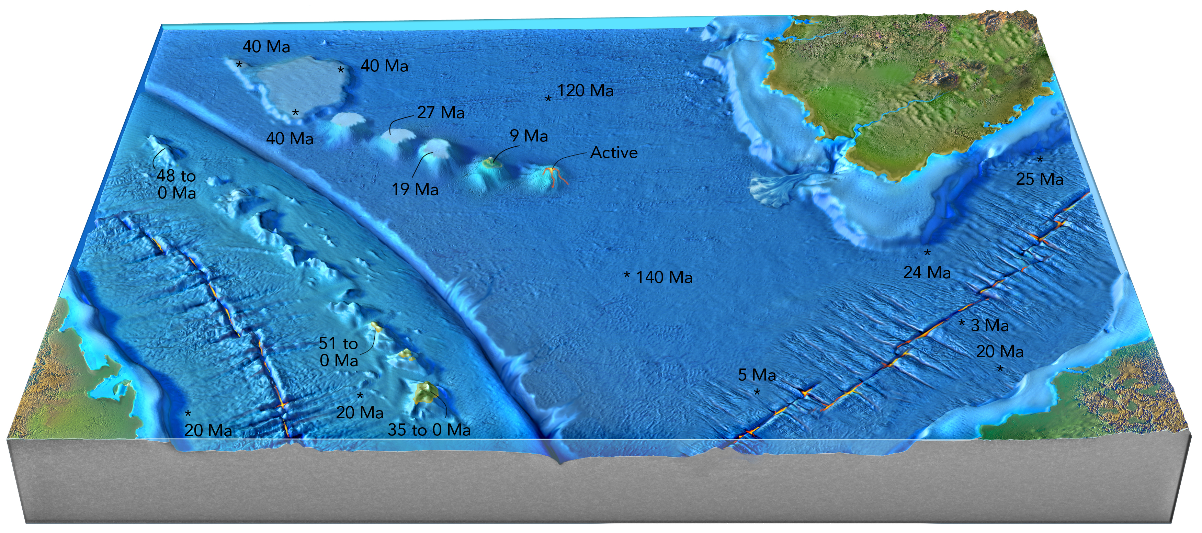
Feature 2:
_________________
Feature 7 (refers to narrow sea
between continent and islands): _____________________________
Feature 8:
_________________
Feature 10:
_________________
Feature 9: _________________
Question 2. Interpretation of the Formation and Relationship of Features
For each of the numbered features on the previous figure, write the name of the numbered feature from the previous diagram in the table below and provide a brief interpretation of how the feature formed. Possible interpretations are in the table below (you can use the letter instead of writing out the answer).
Feature Number | Name of Feature | Interpretation of How Feature Formed
1
2
3
4
5
6
7
8
9
10

Interpretation of How Feature Formed
a. Formed where two oceanic plates converge, and melting caused by the subducted plate results in volcanoes on the overriding plate.
b. Differences in the age of seafloor cause oceanic crust on one side of this feature to be higher in elevation than oceanic crust on the other side, but the feature is not a plate boundary.
c. A rising plume of mantle melts and causes melting of adjacent lithosphere, and magma erupts onto the seafloor.
d. Two oceanic plates diverge, allowing mantle to rise, melt, and form new oceanic crust.
e. Migration of an island arc and trench causes oceanic crust behind the arc to stretch, rift, and spread.
f. Movement of a plate over a hot spot results in a linear chain of volcanic islands and seamounts.
g. Sediment is transported by turbidity currents from the edge of the continent into deeper water.
i. A broad area of continental crust that has been thinned and overlain by marine sediments.
j. Formed by bending down of a slab as it enters a subduction zone.

Instructions for Question 3. Interpreted Relationship Between Adjacent Features
Briefly describe a possible relationship between each pair of features identified below. Possible answers include the following:
a. Oceanic crust is subducted and releases water, which causes magma to rise into the overriding plate.
b. A rising mantle plume causes widespread melting when it first encounters the lithosphere; magmatism continues as the plate moves over the hot spot.
c. Spreading causes two plates to slip past one another along transform faults; differences in elevation reflect differences in the age of the crust.
d. Two oceanic plates diverge, forming a rift, which allows magma to reach the surface.

Question 3. Interpreted Relationship Between Adjacent Features
Related Features | Possible Interpretation of How the Features are Related
Features 1 and 2
Features 3 and 4
Feature 9 and 10

Question 4. Based on the features you identified on the ocean floor, choose the most appropriate cross section from those presented below.
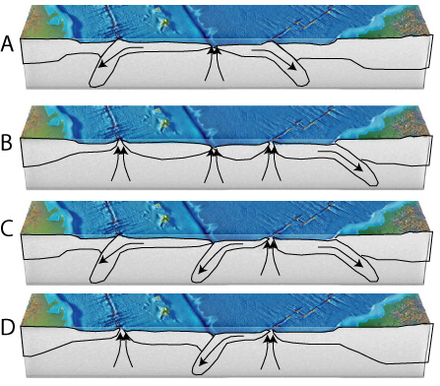
a. Cross section A
b. Cross section B
c. Cross section C
d. Cross section D

